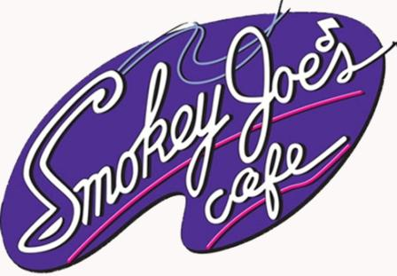

Smokey Joe’s Cafe - The Songs of Leiber and Stoller
Public Service Announcement

May 4, 2012 -- For Immediate Release
Kill Date -- June 29, 2012
Contact -- Christopher M. Montpetit, 205/348-3844, 251/968-6721, cmmontpetit@as.ua.edu

30 Seconds
SummerTide Theatre rocks Gulf Shores with the Tony Award-nominated Smokey Joe’s Café - the Songs of Leiber and Stoller from Friday, June 1st through Friday, June 29th. Tickets are only $18.00 for adults and $12.00 for those 12 and under. Group rates available. Visit SummerTide.org to buy your tickets online now or call the box office at 251/968-6721 starting May 28th. Performances run Tuesday through Sunday evenings at 8:00PM at the George C. Meyer Performing Arts Center in Gulf Shores, Alabama.

15 Seconds
SummerTide Theatre rocks Gulf Shores with Smokey Joe’s Café - the Songs of Leiber and Stoller, Friday, June 1st through Friday, June 29th at the George C. Meyer Performing Arts Center in Gulf Shores. Visit SummerTide.org or call 251/968-6721 for tickets.

# # #

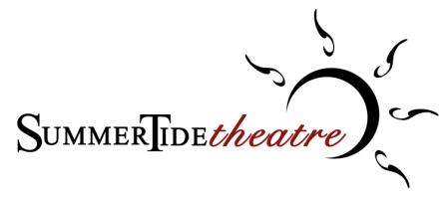
The Professional Summer Theatre of The University of Alabama
________________________________________________________________________________________________________
The University of Alabama, Department of Theatre and Dance, Box 870239, Tuscaloosa, AL 35487-0239
Main Office 205/348-5283 - Fax 205/348-9048 - UATD Box Office 205/348-3400 - Gulf Shores Box Office 251/968-6721
theatre.ua.edu - SummerTide.org

