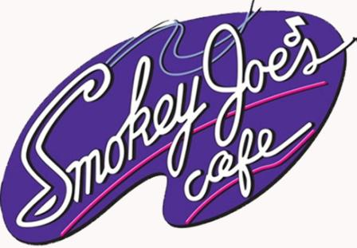

Smokey Joe’s Cafe - The Songs of Leiber and Stoller
Rocks Gulf Shores, Alabama June 1-29

May 4, 2012 -- For Immediate Release

SummerTide Theatre, the professional summer theatre of The University of Alabama, returns for its ninth year to the George C. Meyer Performing Arts Center (home of the South Baldwin Community Theatre) with an electrifying entertainment revue that illuminates the golden age of American culture…Smokey Joe’s Café - the Songs of Leiber and Stoller. Running Friday, June 1 through Friday, June 29, 2012, performances are Tuesday to Sunday evenings at 8:00PM.

Jerry Leiber and Mike Stoller, as much as anyone, virtually invented rock ‘n’ roll, and now their songs come alive on stage in this Tony Award-nominated production. In an idealized 50’s setting, the classic themes of love won and love lost blend with nostalgia and emotions. Featuring nearly 40 of the greatest songs ever recorded, including “Hound Dog”, “On Broadway”, “Charlie Brown”, “Love Potion #9”, “Jailhouse Rock”, “There Goes My Baby”, “Yakety Yak”, “Spanish Harlem”, “Poison Ivy”, and “Stand By Me”, Smokey Joe’s Café isn’t just great pop music -- it’s compelling musical theatre.

Directed by Professor of Theatre and Founding Chairman of the UA Department of Theatre and Dance Dr. Edmond Williams, the cast, in alphabetical order, include Alyssa Grubbs (from Atlanta, GA), Allie Jones (Memphis, TN), Drey Mitchell (Florence, AL), Renee Reinicke (Houston, TX), Corey Rives (Huntsville, AL), Caroline Schmidt (Mandeville, LA), Will Travis (Birmingham, AL), and Adam Vanek (Mandeville, LA).

The musical direction of Smokey Joe’s Café - the Songs of Leiber and Stoller is by Raphael Crystal, with choreography by Stacy Alley. Costume design is by Donna Meester, with scenic design by Andy Fitch and lighting and sound design by Bill Teague. Spencer Collins (from Winston Salem, NC) serves as technical director, with Karen Baker (Margate, FL) as stage manager. Piano provided by Terry Moore. SummerTide Theatre’s Business Manager is Christopher M. Montpetit, with Amber Gibson (Huntsville, AL) serving as Assistant Business Manager.

Since 2004, The University of Alabama’s College of Arts and Sciences Department of Theatre and Dance has presented professional theatre in Gulf Shores, Alabama. These productions are designed and directed by UA professors, and feature UA students from the musical theatre program. Previous years have been very successful in attracting and pleasing audiences from south Alabama and all over the United States.

Smokey Joe’s Café, produced through special arrangement with R&H Theatricals, will run Friday, June 1 to Friday, June 29, 2012, with performances every Tuesday through Sunday evening at 8:00PM at the George C. Meyer Performing Arts Center. Tickets may be purchased online 24/7 by visiting SummerTide.org . Until May 27th, tickets may be purchased by calling The University of Alabama Box Office (in Tuscaloosa) at 205/348-3400 or the Gulf Shores Box Office at 251/968-6721 starting May 28th. In Gulf Shores, the Smokey Joe’s Café box office will be open Tuesday through Sunday, from 12:00Noon to 8:00PM. Tickets prices are $18.00 for adults and $12.00 for children under 12. Groups of 10 or more are $12.00 each. The George C. Meyer Performing Arts Center, home to the South Baldwin Community Theatre, is located at 2022 West 2nd Street in Gulf Shores, Alabama.

SummerTide Theatre is made possible by the Herbert Clark West Endowed Support Fund at The University of Alabama, The University of Alabama National Alumni Association, The University of Alabama Office of the Provost, The University of Alabama College of Arts and Sciences, the George C. Meyer Foundation, the Erie Hall Myer Charitable Fund, and the Alabama Credit Union. Additional support is provided by the Alabama Gulf Coast Convention and Visitors Bureau, South Baldwin Community Theatre, Sunset Properties, James V. Roberts PC, Mark & Karen Reynolds, and the Bama Breakfast Group. The UA Department of Theatre and Dance is part of the College of Arts and Sciences, UA’s largest division and the largest liberal arts college in Alabama.

Contact: Christopher M. Montpetit, Business Manager
205/348-3844, cmmontpetit@as.ua.edu

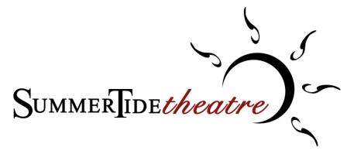
The Professional Summer Theatre of The University of Alabama
________________________________________________________________________________________________________
The University of Alabama, Department of Theatre and Dance, Box 870239, Tuscaloosa, AL 35487-0239
Main Office 205/348-5283 - Fax 205/348-9048 - UATD Box Office 205/348-3400 - Gulf Shores Box Office 251/968-6721
theatre.ua.edu - SummerTide.org

